EX 16. Use Google & Who.is for Reconnaissance
microsoft.com
WHOIS Information
IP Address: 150.171.109.71
WhoisRDAPDNS RecordsCertificateUptimeDiagnosticsHistoryHide Contact Info
Refresh Data
The domain microsoft.com is registered. You can still try to buy it here.
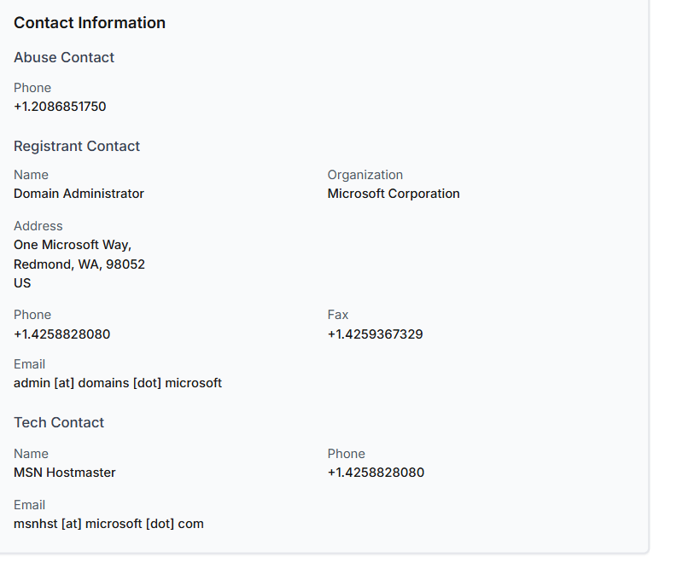
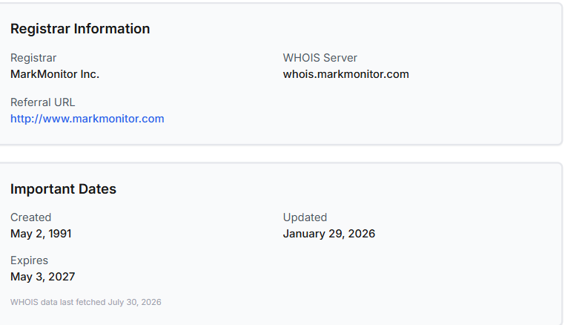
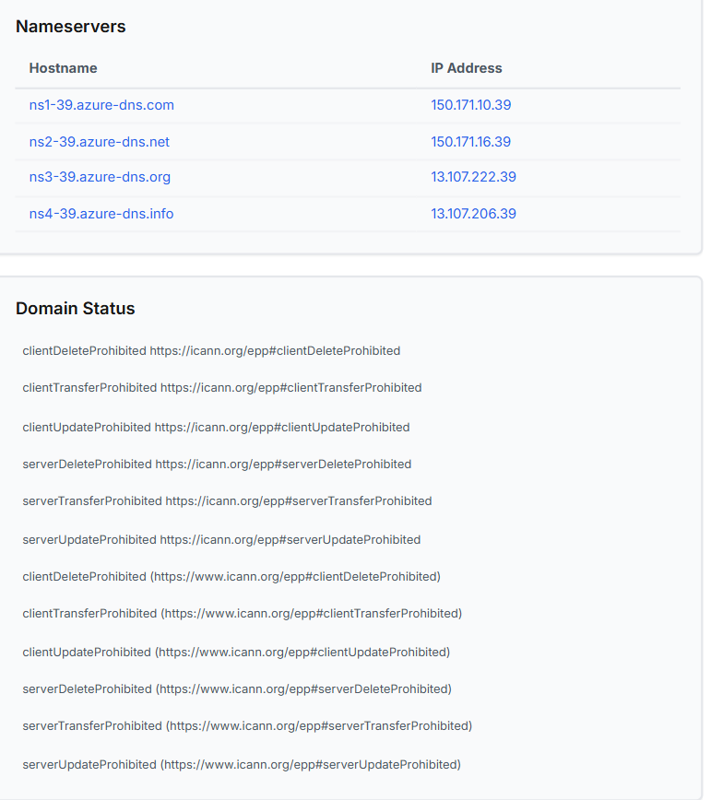
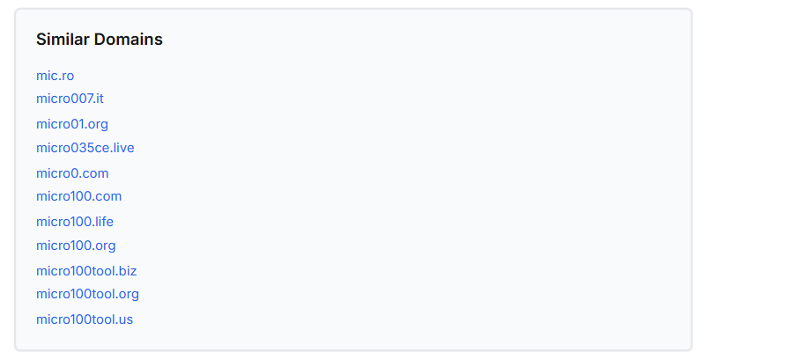

DNS RECORD
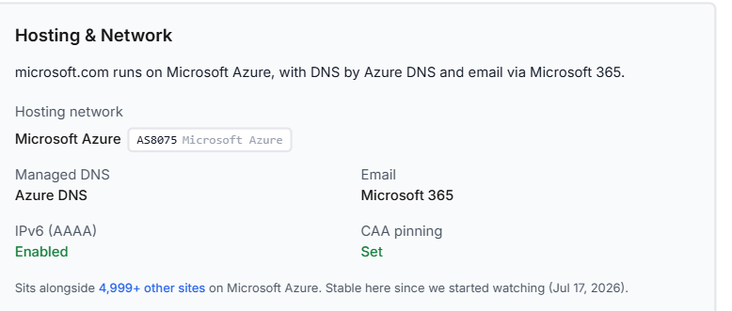
DNS Records for microsoft.com
Hostname | Type | TTL | Priority | Content
microsoft.com | SOA | 300 |  | ns1-39.azure-dns.com azuredns-hostmaster.microsoft.com 1 3600 300 2419200 300
microsoft.com | MX | 0 | 10 | microsoft-com.mail.protection.outlook.com
microsoft.com | NS | 0 |  | ns2-39.azure-dns.net
microsoft.com | NS | 0 |  | ns1-39.azure-dns.com
microsoft.com | NS | 0 |  | ns3-39.azure-dns.org
microsoft.com | NS | 0 |  | ns4-39.azure-dns.info
microsoft.com | CAA | 0 |  | 0 contact caarecordaware@microsoft.com
microsoft.com | AAAA | 0 |  | 2603:1061:14:40::1
microsoft.com | A | 0 |  | 150.171.110.193
microsoft.com | TXT | 0 |  | v=MCPv1; k=ecdsap384; p=Asc8WWov6gsmCCzn4CSrwRuJIh5SqvaitKz/LlTW+SD54lLC52wzcnWhlTI416p2vw==
microsoft.com | TXT | 0 |  | google-site-verification=uhh5_jbxpcQgnb-A7gDIjlrr5Ef34lA2t2_BAveYpnk
microsoft.com | TXT | 0 |  | v=MCPv1; k=ecdsap384; p=AoHTKEi2W8L2P8cf9CoDicIxYiuttTkwtIeFOqYCewBGoRZiiF+9/92saUkIDERGAA==
microsoft.com | TXT | 0 |  | v=MCPv1; k=ecdsap384; p=A8a5Z0fMroXSzLT+NXb33SxWJZ7UTZdFO3qcknLCGeGpLOLeFpxT4YamxRLfZKUaHg==
microsoft.com | TXT | 0 |  | ms-domain-verification=25524f4b-1476-489c-a086-30f4c5016ecc
microsoft.com | TXT | 0 |  | hpe-greenlake-domain-verification=495143304a3330533363357a57684f6335556f316f55654675523541464d3954
microsoft.com | TXT | 0 |  | v=MCPv1; k=ecdsap384; p=AqXeTHJ/1FCYeuvJ8dc1B+X3uHaa7m2W0s31vzL4opnrJlSaBdtbWTY8Ti5WiZnu9Q==
microsoft.com | TXT | 0 |  | _zx2p8gpzv720db2aqmozy4jhwk2nl43
microsoft.com | TXT | 0 |  | d365mktkey=j2qHWq9BHdaa3ZXZH8x64daJZxEWsFa0dxDeilxDoYYx
microsoft.com | TXT | 0 |  | d365mktkey=wbU64GRacxVEQxwcLSQnx0zisXLYzgUbfvsufIqO9ZUx
microsoft.com | TXT | 0 |  | d365mktkey=QDa792dLCZhvaAOOCe2Hz6WTzmTssOp1snABhxWibhMx
microsoft.com | TXT | 0 |  | hcp-domain-verification=3ce174a8b9fba88909633ab13eb1d81ce0123454745d66e500052ed84b7248a1
microsoft.com | TXT | 0 |  | v=MCPv1; k=ecdsap384; p=An4mJIFLRys9h1EvjX18SJs5p1uEF5MHcs2JJLYPrI48C5Qt9FpaZEM0sQTV4JvNYw==
microsoft.com | TXT | 0 |  | d365mktkey=Fu49WtSTeClkHtK7S14227RIVpGwwGrzEsO6RVs1I2Ax
microsoft.com | TXT | 0 |  | v=MCPv1; k=ecdsap384; p=A/Mf6IKdZzcHfBvpiVz9rkdPTIcCP5IbRDdEkeP3PgXEXF3mNjorahOwaYlMINBF5A==
microsoft.com | TXT | 0 |  | facebook-domain-verification=fwzwhbbzwmg5fzgotc2go51olc3566
microsoft.com | TXT | 0 |  | d365mktkey=3l6dste9txazu0Qd2zu4135PUB4E35txLxyzJxjkPbsx
microsoft.com | TXT | 0 |  | dobtdihqagnr18hea8uv1h1mvq
microsoft.com | TXT | 0 |  | d365mktkey=PNcDqkW71x8VOUhcE96aGM4l5PYX1gnlRl6ieXUl5eMx
microsoft.com | TXT | 0 |  | ms-domain-verification=d6545068-89f7-4432-b947-0b137e8a9fe3
microsoft.com | TXT | 0 |  | v=MCPv1; k=ecdsap384; p=Azw9+u4M8RoH+bxJidKAZzGDmsPkzY1N4cO7rB/uC5x1RBoNfMyBlH/ott0lpo4pOQ==
microsoft.com | TXT | 0 |  | google-site-verification=pjPOauSPcrfXOZS9jnPPa5axowcHGCDAl1_86dCqFpk
microsoft.com | TXT | 0 |  | mixpanel-domain-verify=5803bc4c-5bb6-4ce1-8076-753800097373
microsoft.com | TXT | 0 |  | liveramp-site-verification=kxcV8fDH_FUNUZQEcAO6lwgim47f_hNLgMP4VG0PF_Q
microsoft.com | TXT | 0 |  | v=MCPv1; k=ecdsap384; p=AzTrmHtbRqr8G+xzm+T4LvNfN5678x6/tlK7kC2enHfH73WkH6AHXsQeXog0+RVjlg==
microsoft.com | TXT | 0 |  | sitecore-domain-verification=1d46cb5467624e33a408d14324874088
microsoft.com | TXT | 0 |  | 1password-site-verification=35ZTURTFFFDC5BW7GFQKRJ77QM
microsoft.com | TXT | 0 |  | v=MCPv1; k=ecdsap384; p=A8qndBCDJGtFF2+3v/IPIMmM0SaVcrJBoSue7rKob6sUeK7QGeFuWkrtvze3AiqUDA==
microsoft.com | TXT | 0 |  | hubspot-developer-verification=OTQ5NGIwYWEtODNmZi00YWE1LTkyNmQtNDhjMDMxY2JjNDAx
microsoft.com | TXT | 0 |  | google-site-verification=M--CVfn_YwsV-2FGbCp_HFaEj23BmT0cTF4l8hXgpvM
microsoft.com | TXT | 0 |  | airtable-verification=79a09e4a8013ff5737798ffb4ea88eee
microsoft.com | TXT | 0 |  | d365mktkey=SxDf1EZxLvMwx6eEZUxzjFFgHoapF8DvtWEUjwq7ZTwx
microsoft.com | TXT | 0 |  | t7sebee51jrj7vm932k531hipa
microsoft.com | TXT | 0 |  | ms-domain-verification=561512fc-b4ba-4ac7-a946-e464c8f49f1b
microsoft.com | TXT | 0 |  | v=MCPv1; k=ecdsap384; p=Al9O7vaY4u02Vzh6c6i9ie3AFUHq9j3VK9rFROTJsCx5Rh0ailSEc3/k8fyCbjrHLQ==
microsoft.com | TXT | 0 |  | d365mktkey=6358r1b7e13hox60tl1uagv14
microsoft.com | TXT | 0 |  | workplace-domain-verification=lK0QDLk73xymCYMKUXNpfKAT8TY5Mx
microsoft.com | TXT | 0 |  | openai-domain-verification=dv-sFtCvKOlWoe31gpoSvs7cqsP
microsoft.com | TXT | 0 |  | d365mktkey=3uc1cf82cpv750lzk70v9bvf2
microsoft.com | TXT | 0 |  | docusign=d5a3737c-c23c-4bd0-9095-d2ff621f2840
microsoft.com | TXT | 0 |  | atlassian-domain-verification=xvoaqRfxSg3PnlVnR4xCSOlKyw1Aln0MMxRiKXnwWroFG7vI76TUC8xYb03MwMXv
microsoft.com | TXT | 0 |  | v=MCPv1; k=ecdsap384; p=AorzdBrk9vGOZL9e5z5QMIwNhati9xM/jjeNpBQkzfdZ6nhG6KQTaVQRBr06xvTvIg==
microsoft.com | TXT | 0 |  | anthropic-domain-verification-phksss=GZrrKDUR4klRLFCvxyOvqcNGE
microsoft.com | TXT | 0 |  | d365mktkey=ZGFU0tlXPekPusNHPo5QQQWpVf0gic0xpuKroNy3NQEx
microsoft.com | TXT | 0 |  | google-site-verification=uFg3wr5PWsK8lV029RoXXBBUW0_E6qf1WEWVHhetkOY
microsoft.com | TXT | 0 |  | zoom-domain-verification=ZOOM_verify_e97a3d385acb4c47b9b924609a280524
microsoft.com | TXT | 0 |  | v=MCPv1; k=ecdsap384; p=As/XxnDWZFxFwHvRZj+HbG5/ImtAeabLkiOWu1h7wCJQFAR216E9HoYQ5Hy6o7StoQ==
microsoft.com | TXT | 0 |  | d365mktkey=8fEQahTresJms7tZGxGFr94T1zDz36oCbUt1LJc99mox
microsoft.com | TXT | 0 |  | fg2t0gov9424p2tdcuo94goe9j
microsoft.com | TXT | 0 |  | ms-domain-verification=478640ad-6524-43d5-86c4-a914804b9e93
microsoft.com | TXT | 0 |  | linear-domain-verification=iuq6saifcnbe
microsoft.com | TXT | 0 |  | d365mktkey=heYmJ57sWrwMjCgIG1xRwTREJrQokUIDtBcNfGuxoWQx
microsoft.com | TXT | 0 |  | ms-domain-verification=1c4e4677-e58f-4117-8d61-e5b2810388c2
microsoft.com | TXT | 0 |  | v=MCPv1; k=ecdsap384; p=Atv9t87le3AkxabGQAy75Wju8M3YATC1mPNp/3BQepwz5KS+4VwTtTq7ZSjHAPFXzw==
microsoft.com | TXT | 0 |  | MS=ms79629062
microsoft.com | TXT | 0 |  | atlassian-domain-verification=Sn5AwyIdVgkaRaJA/IKj7ZFMnWeCBnppa9bXGLuJvsakRHH4lYoBxS8g7GVlud9M
microsoft.com | TXT | 0 |  | google-site-verification=GfDnTUdATPsK1230J0mXbfsYw-3A9BVMVaKSd4DcKgI
microsoft.com | TXT | 0 |  | v=spf1 include:_spf-a.microsoft.com include:_spf-b.microsoft.com include:_spf-c.microsoft.com include:_spf-ssg-a.msft.net include:_spf1-meo.microsoft.com -all
microsoft.com | TXT | 0 |  | d365mktkey=JlXV17lfZjyvWxNje1qiP390ACSKzTxo5mGqZ3V2BmYx
microsoft.com | TXT | 0 |  | google-site-verification=mEAmcTy1e8jIB9W6ENPk2GDg9hjuNytQQRGlK0hPm0c
microsoft.com | TXT | 0 |  | ms-domain-verification=65f91178-9dfb-41cd-929d-08d1a38ed607
www.microsoft.com | CNAME | 0 |  | www.microsoft.com-c-3.edgekey.net
www.microsoft.com | AAAA | 0 |  | 2600:1408:c400:f84::356e
www.microsoft.com | AAAA | 0 |  | 2600:1408:c400:f8c::356e
www.microsoft.com | AAAA | 0 |  | 2600:1408:c400:f85::356e
www.microsoft.com | AAAA | 0 |  | 2600:1408:c400:f94::356e
www.microsoft.com | AAAA | 0 |  | 2600:1408:c400:f92::356e
www.microsoft.com | A | 0 |  | 23.48.10.36

What's up with DNS →
Our daily roundup of the most interesting DNS changes across the web — hosting and CDN migrations, network moves, and security-config shifts.

Ask about microsoft.com
Beta
Answers use the live DNS records shown on this page. AI-generated — double-check anything important.

Ask

Where does email for microsoft.com go?Who runs DNS for microsoft.com?Why is www.microsoft.com a CNAME?
Get alerted the moment microsoft.com's DNS changes
This page is today's snapshot. Turn on monitoring and we'll watch microsoft.com continuously, notifying you the moment anything moves across all three signals:
Uptime
We visit the site from multiple regions worldwide and email you within minutes if it goes down, with a per-region breakdown so a real outage stands out from a regional blip.
DNS changes
We watch NS, MX, CAA, DNSSEC, CNAME and A/AAAA records, and identify the host, network, and ASN behind them, so a real migration or hijack stands out from routine noise.
TLS certificate
We warn you 30, 14, 7, and 1 days before it expires, and flag it if the issuing authority changes or the certificate is unexpectedly replaced.
Monitor DNS free
Free for your first domain: uptime, DNS, and certificate together. No credit card.

